Instructions for ONLINE officiating training for Players and Coaches
Read all instructions before starting. The link to the online training website is included in these instructions!
Step 1 – Create a user id
Select the CREATE NEW STUDENT option when first accessing the website.
Note: This is required even if you did online training last year. This is a new system
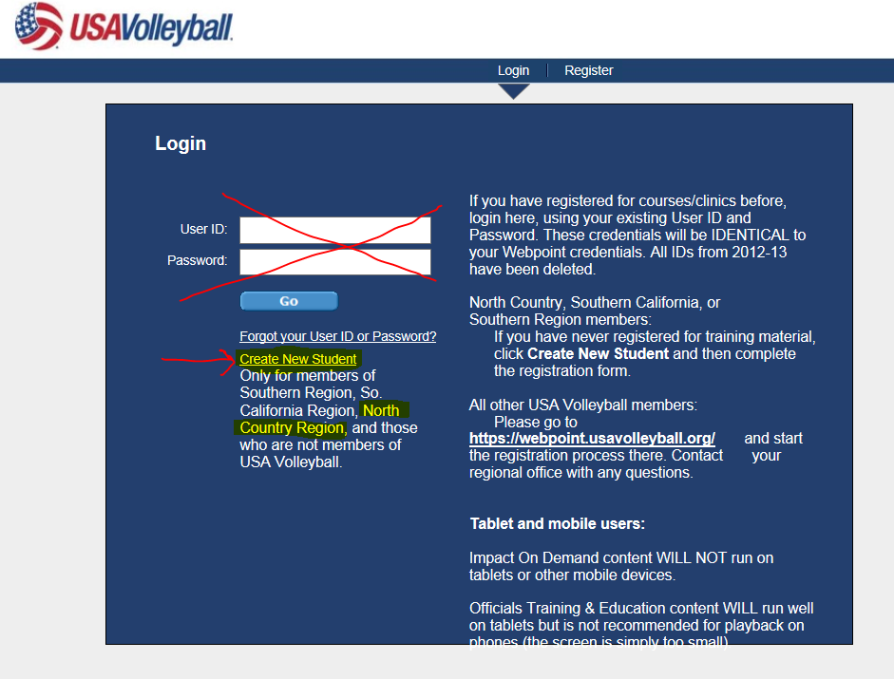

Here is a summary regarding the Training levels that are available to select from:
Basic – This only covers line judging and libero tracking and is designed if you will not referee or score during the season. This lower level should only be taken if approved by your coach.
Level 1 – This does not cover refereeing responsibilities and is designed for those that will ONLY be scorers during the season. This lower level should only be taken if approved by your coach.
Level 2 – Required for any player that will be an R2 at any point in the season. This is the highest level recommended for the U12 and younger ages, as the coach is required to be the R1 for all matches at this age.
Level 3 – Required for ALL coaches and any player (age 13+) that may be an R1 at any point during the season.

Step 2 – Accurately complete all required information, as described and shown below.
- Your user id must be your email address. Read the note if more than one person will be using the same email address.

- Ensure that NORTH COUNTRY is selected as the Region. Failure to do this will not bring up the proper courses, thus you will NOT get credit for completion.

- Ensure you put your club name in the available space.

- Do not fill out the USA membership # or contact id. Leave the referee rating information blank.
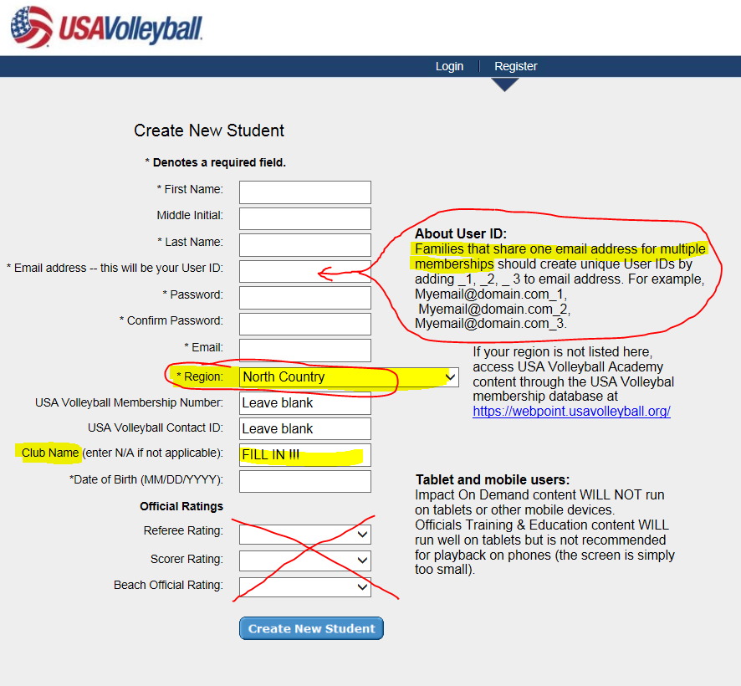

Step 3 – This system will bring up all of the possible training options for our Region. During this time the system will also generate several emails, which may end up in your SPAM/Junk folder, indicating that you are enrolled in all of listed curriculum. These messages are not necessary to save and can be deleted.
You will NOT need to complete all of the curriculum. You will be selecting ONE!!

Coaches of U15-U18 teams – select NO105
Coaches of U14 and younger – select NO104

Players on U15-U18 teams – select NO105
Players on U13-U14 teams – select NO104

Players on U12 and younger – select NO103 (this covers all training except R1, as for this age the coach, or adult member on the roster, must be the up referee)
For players approved by their coach to only score/libero track/line judge – select NO102
For players approved by their coach to only libero track or line judge – select NO101
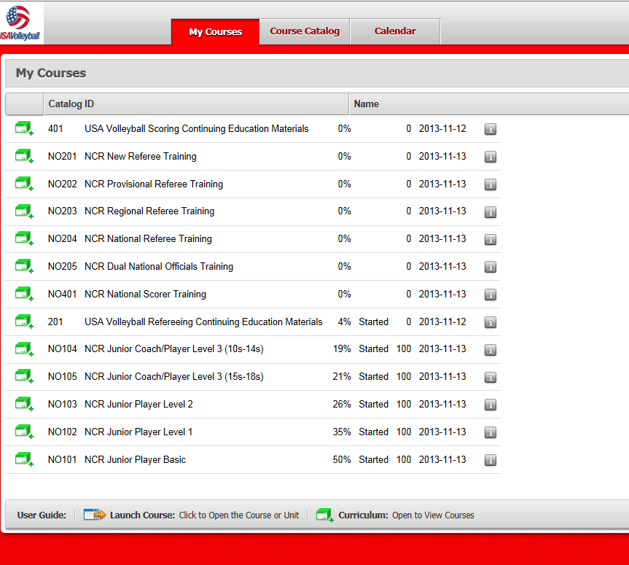

Step 4 – Select the proper group of training modules by clicking on green box/+ sign.
This will open up all of the courses within the curriculum.
For our example, we’ll be a U17 team coach, so the proper selection would be NO105.
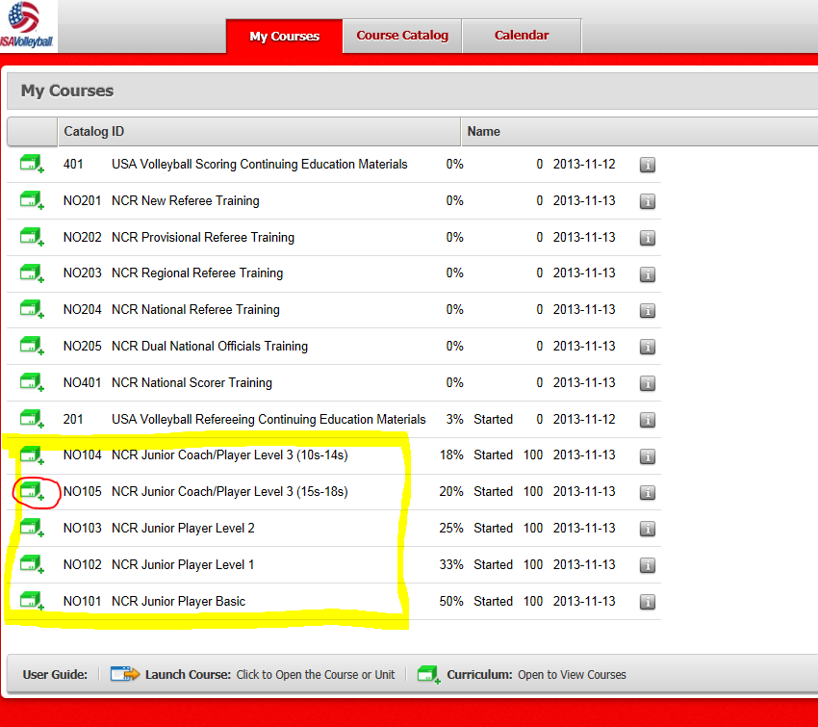

After clicking the green box, the courses will show up and you can select any of them. However, I strongly recommend going in order from top-to-bottom.

Step 5 – Select the course you’d like to take by clicking on the blue box with a yellow arrow.
In this example, we’ve already completed the Line Judge training and quiz and are moving on to select the Scorer training.
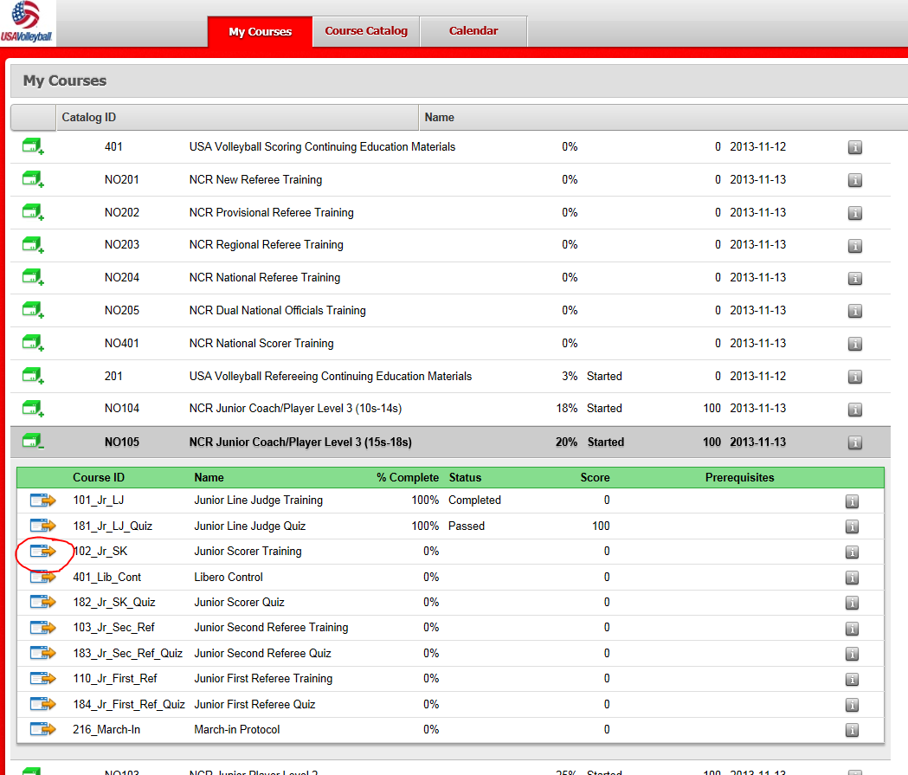

Please note that for any questions up to this point, do NOT contact USAV volleyball. Please send an email to brad@ncrusav.org with the subject line: Online help.
Once you click on the course, it will open a new window that will contain the presentation material. This may take several moments to load, depending on your connection, and may appear as a blank screen for several seconds. It will be necessary to ensure you are using audio at this point to hear the voice over for the slides.
Should you run technical into issues from this point on, please select the help resources at the top of the page. I will not be able to assist with any problems that arise during the video.
Step 6 – You will need to interact with the software. At the end of each slide you must click the advance button. When you are taking quizzes, please note the wording, as several questions allow/require multiple boxes to be checked. Should you not score 100%, you will need to re-take the quiz, but will be allow to review the correct answers before closing out.

Step 7 – There is no need to complete all of the training at once. Your progress will be saved and you can come back to where you last finished. Just re-launch the website http://bit.ly/ncronline and this time you should enter in your user id and password, rather than clicking on create a new student.

Step 8 – You will receive an email (w/ a pdf certificate) at the completion of every course within the curriculum. You will also receive an email at the completion of the entire level. Please email ONLY your LEVEL completion to your coach (not each course!). This MUST be completed within 1 month of the start of your season, or earlier if your coach requests. It is strongly recommended the training is complete before participating in competition.

Step 9 - Enjoy your season. Please feel free to ask questions if you have a certified referee or an officials’ trainer present at one of your events. They are there to help all participants better understand the rules and techniques of scoring and officiating. Taking the opportunity to referee during your junior playing years can assist you with future chances for employment as a referee. I know I’d rather referee park-n-rec at college than clean floors or cook food…but, that’s just me!

Step 10 - Keep your same email address! Next year’s training will then be shorter, building on what you complete this season. This will only be possible if you use the same user id.

